Adminshared/20-21/general letters/fkg/parentletter/28.5.21 KS
28 May 2021

Dear Parent/Guardian

Thank you for your support, understanding and patience during what has been the most difficult of times.

I am delighted that we have managed to welcome all pupils back to school this half term without the need for any year group self-isolation and equally that the school is beginning to be more ‘normal’ again.

In general the pupils have been excellent and I feel I must specifically mention Years 11, 12 and 13 who have shown great resilience and determination in the way they have managed their assessments which will provide their GCSE/AS/A Level grades. They have been a credit to the school and to you as parents and guardians.

There will be a small change to the timings of the staggered end to the school day after half term.

Years 7 & 8 will now leave at 2.55pm
Years 9, 10 & 12 will now leave at 3.00pm

Finally I hope you all manage to have a relaxing and enjoyable half term and we look forward to welcoming all pupils back on 7 June 2021.

Yours faithfully

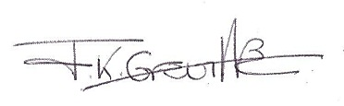

Mrs F K Greville
Headteacher

