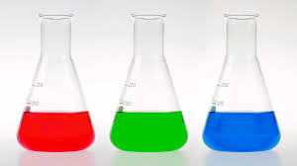

Science/Gwyddoniaeth

Dear Year 6,
We look forward to seeing you at Llantwit Major School where you will find us on the top floor of L Block. Science is such an endlessley fascinating and ever-changing subject that we are sure there are lots of topics for you to enjoy at Key Stage 3. You will meet different science teachers who each have their own interests in the different areas of biology, chemistry or physics and will enjoy talking to you about them!
Pupils say that one of their favourite parts of science at KS3 is the extended research project. The idea behind this is for you to choose and then complete an extended activity that links and extends an area of science you have covered in lessons and enjoy.
You can get ready for life at school with us by learning some spellings we use in science all of the time. You will be given a spelling test on the keywords for each topic you cover. We have a word search to go along with each spelling list.
Below is a word search for you to try and a list of key words that you will need to spell for your first spelling test in science from the Science Skills unit. Have a go at them!

Good luck!
Mrs Birt
Curriculum Leader for Science

Spellings for the skills unit:
Beaker
Conclusion
Evaluation
Hazard
Metre
Scientific
Bunsen
Corrosive
Flammable
Laboratory
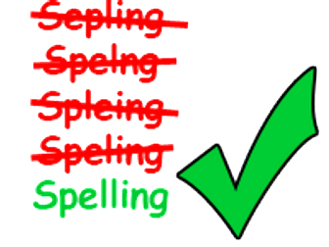
Safety
Temperature
Burner
Cylinder
Gauze
Measuring
Science
Thermometer

Skills Spelling test

T | C | T | R | W | O | Z | Q | M | G | K | C | L | L | N
C | E | C | N | E | I | C | S | N | O | Y | Y | A | Q | O
Y | R | M | U | O | N | B | I | Q | L | Y | B | D | U | I
N | T | M | P | E | I | R | E | I | O | O | U | R | C | T
H | G | E | S | E | U | S | N | A | R | D | T | A | O | A
M | C | N | F | S | R | D | U | A | K | G | H | Z | R | U
X | U | A | A | A | E | A | T | L | F | E | E | A | R | L
B | D | E | A | R | S | O | T | T | C | Z | R | H | O | A
A | M | C | R | E | R | Y | B | U | T | N | M | I | S | V
N | G | U | Q | Y | S | S | L | P | R | C | O | V | I | E
C | I | F | I | T | N | E | I | C | S | E | M | C | V | G
F | L | A | M | M | A | B | L | E | N | E | E | N | E | A
B | U | R | N | E | R | F | A | J | T | U | T | F | A | U
U | Q | R | Z | Y | B | W | H | R | S | B | E | B | E | Z
C | E | E | W | D | Y | R | E | B | R | D | R | T | G | E

BEAKER | BUNSEN | BURNER
CONCLUSION | CORROSIVE | CYLINDER
EVALUATION | FLAMMABLE | GAUZE
HAZARD | LABORATORY | MEASURING
METRE | SAFETY | SCIENCE
SCIENTIFIC | TEMPERATURE | THERMOMETER

