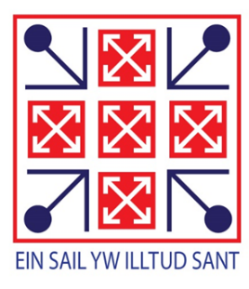
Llantwit Major Science Department

Organisation
The department comprises seven, brand new rooms and one preparation area situated on the top floor of the new school building. The accommodation is a mixture of full laboratories, demonstration studios and teaching classrooms. The team consists of eight full-time and one part-time teacher with two laboratory technicians. There is one Director of Science and two Assistant Leaders of Science working closely with the science team to drive forward the highest standards of teaching and learning in this core subject. All members of the department are committed to providing a high quality science education for all which manifests itself in the form of very good results throughout the Key Stages.

Curriculum
At Key Stage Three, science is taught for six hours each fortnight in both years 7 and 8; years 9, 10 and 11 are taught for nine hours. The department has embraced the Key Stage Three skills curriculum and has good quality schemes of work, resources and assessment materials. Assessment for Learning and Thinking Skills techniques are incorporated at every opportunity.
The science GCSE courses are taught over three years from year 9 to 11. One MAT Triple Award GCSE group in each year group is taught for an additional 4 hours a fortnight in years 10 and 11. Most pupils are taught Double Award Science GCSE specification. The first examination units are taught in year 10 followed by the second units in year 11. Classes are taught by subject specialists who remain with their classes for the whole GCSE course to ensure consistency and continuity. There is a system of science tutors in place to monitor, challenge and support all pupils at GCSE.
In years 12 and 13 WJEC Biology, Chemistry, Physics and Pearson/Edexcel Level 3 Applied Science are taught for eight hours per fortnight. These courses are very popular, with the majority of pupils opting to study the subjects at higher education. The Triple Award group provides the majority of pupils for the A level courses. The department runs a variety of MAT science excursions e.g. last year approximately 40 pupils participated in a week-long trip to Iceland after a trip to CERN in the previous year. Such is the enthusiasm for these activities, from both staff and pupils, we are in the process of organising a return visit to CERN for 2021. We know from Listening to Learners our pupils value these opportunities to broaden their horizons and enjoy science in a real life context.

Resourcing
The department teaches to a unit system throughout the Key Stages and has a system of setting homework via assessment booklets in years 7-11. In addition to regular written/practical tasks and tests in class there are also short tests set by class teachers in individual google classrooms for each unit taught throughout each of the year groups. Each pupil is given a classroom code in order to access support materials e.g. to complete assessment tests, homework tasks, access past papers/mark schemes/revision materials for all tests/examinations and also to provide extra copies of class resources/PowerPoints,. The ‘Connecting Science’ text is used as a stimulus material at Key Stage Three to supplement our in-house system. The GCSE and A level courses are supported by Bangor Resources and the Illuminate textbooks and revision materials in addition to teacher materials.

