

**Pupil and Parent  
 Information Pack**

***A School for the 21st Century at the Heart of the Community***

**People are our greatest asset**



**Llantwit Major School**

**Ysgol Llanilltud Fawr**

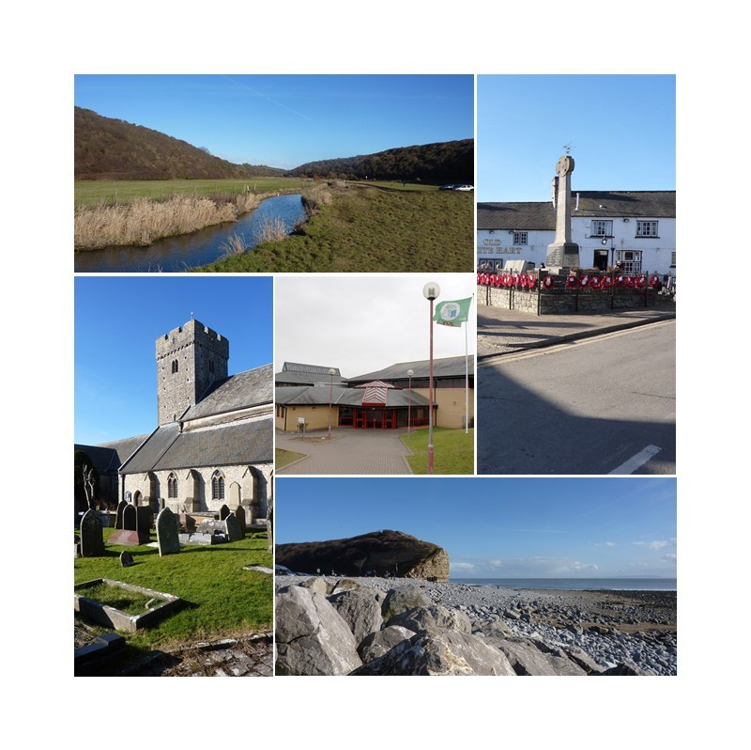



**Llantwit Major School**

**Ysgol Llanilltud Fawr**

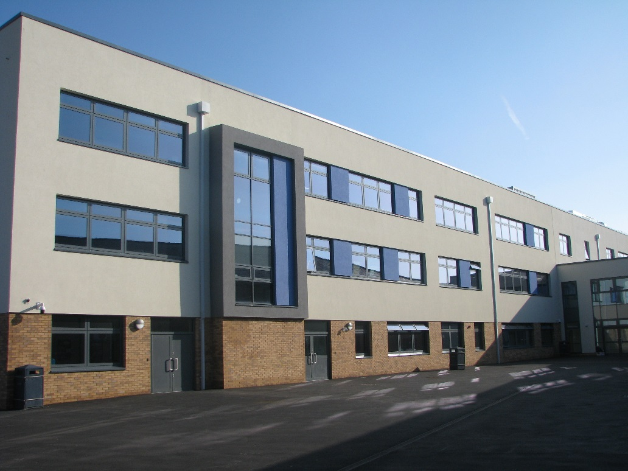

**Address:**

**Ham Lane East**

**Llantwit Major**

**Vale of Glamorgan**

**CF61 1TQ**

**Telephone: (01446) 793301**

**Email:** [**llantwitmajorhs@valeofglamorgan.gov.uk**](mailto:llantwitmajorhs@valeofglamorgan.gov.uk)

**Website:** [**www.llantwitschool.org.uk**](http://www.llantwitschool.org.uk)

**Welcome from the Headteacher**

It is my great pleasure and privilege to welcome you to Llantwit Major School. I am delighted that you have chosen us for the next stage of your child’s education and very much look forward to working closely with you over the coming months and years.

Llantwit Major prides itself on being a school that is fully inclusive. We believe that every child deserves the opportunity to succeed and flourish, regardless of background or ability. We know that people are our greatest asset and are fully committed to excellence, creativity and innovation in order to provide our young people with exciting, enriching and lifelong learning experiences.

We pride ourselves on the strong links we have forged with our local community here in Llantwit Major. Parents also play a crucial part in the life of our school and your cooperation and support is greatly valued and appreciated.

The move to a new school is an important step in any young person’s life and one not to be taken lightly. I hope you find this information useful and that it gives you a flavour of Llantwit Major School and the opportunities we can offer your child.  If you have any further questions after reading it then a wealth of information can be found on our school website  <http://www.llantwitschool.org.uk>

**Mrs C Robins**

Headteacher/Pennaeth

Llantwit Major School/ Ysgol Llanilltud Fawr

# Llantwit Major School Staff

|  |  |
| --- | --- |
| **Senior Leadership Team** | |
| Headteacher: | **Mrs C L Robins** |
| Deputy Headteacher: | **Mrs L Pownall** |
| Assistant Headteachers:  Chair of Governors: | **Mr D Davies**  **Mr K Francis**  **Mrs J Johnson** |
| Business Manager: | **Mrs L Tomsa** |

# Term Dates and the School Day

|  |  |  |  |  |
| --- | --- | --- | --- | --- |
| **TERM** | **START DATE** | **HALF**  **Begins** | **TERM**  **Ends** | **END DATES** |
| **Autumn**  **2024** | **Monday\***  **2 September 2024** | **Monday**  **28 October 2024** | **Friday**  **1 November 2024** | **Friday**  **20 December 2024** |
| **Spring**  **2025** | **Monday**  **6 January 2025** | **Monday**  **24 February 2025** | **Friday**  **28 February 2025** | **Friday**  **11 April 2025** |
| **Summer**  **2025** | **Monday**  **28 April 2025** | **Monday**  **26 May 2025** | **Friday**  **30 May 2025** | **Monday\*\***  **21 July 2025** |

**Inset Day 1 Monday 2 September 2024\***

**Inset Day 2 Tuesday 3 September 2024**

* **Y7 will start on Wednesday 4 September 2024**
* **Y11 and Y12 will return on Wednesday 4 September 2024**
* **All year groups in school on Thursday 5 September 2024**

**Inset Day 3 T.B.C**

**Inset Day 4 T.B.C**

**Inset Day 5 T.B.C**

**Inset Day 6 Monday 21 July 2025\*\***

**May Bank Holiday Monday 5 May 2025**

**The School Day**

The School operates a two week timetable.

Pupils are expected to be in school at 08.20. The timetable for the day is as follows:

|  |  |
| --- | --- |
| **School Day** | **All Years** |
| Registration | 08:30 – 08:50 hrs |
| Period one | 08:50 – 09:50 hrs |
| Period Two | 09:50 – 10:50 hrs |
| Break | 10:50– 11:10 hrs |
| Period Three | 11:10 – 12:10 hrs |
| Period Four | 12:10 – 13:10 hrs |
| Lunch | 13.10 – 14:00hrs |
| Period Five | 14.00 – 15:00 hrs |

NOTE: We attach great importance to punctuality and regular attendance, both of which are monitored closely. Please ensure that if your child is ill, you report this on classcharts, telephone the school attendance line or email attendance on [attendance@llantwitschool.org.uk](mailto:attendance@llantwitschool.org.uk) answerphone. Ideally, it is wise that a call is made every day that your child is absent, or if you know your child will be absent or a period of time, then inform us of that on the first day.

# Emergency Telephone Contact

Parents and Carers are requested to provide the school with telephone contact numbers for use in emergencies. It will then be possible, should the need arise, for parents/carers to be contacted either at home or at the place of work etc. ***Please inform the school promptly if these details or telephone numbers change.***

# Medical and Dental Inspections and Appointments

Wherever possible please arrange appointments outside of school hours. Pupils with appointments during school hours are asked to bring their appointment card to the school. In order that the necessary checks may be made for registration purposes, pupils should sign out at the office before leaving the school premises and sign back in on return.

# Healthy Eating

The school canteen operates a healthy eating menu with many meals having a higher fibre, lower fat and sugar content, than has been traditionally. It is hoped that parents will actively support these initiatives and encourage the pupils to follow healthy eating habits. The school has also achieved the National Quality Award for Healthy Schools. No items with peanuts in are allowed in school.

**Lunch Arrangements**

**On Day 1 parents will be required to provide a packed lunch for Year 7 pupils.**

From day 2, pupils may either:

* purchase lunches prepared at the school; or
* they may bring a packed lunch.

# School Lunches

The School operates a cashless system. All pupils wishing to purchase meals or snacks from the canteen will be issued with a pin code.

In an attempt to remove all cash from school we are asking all parents to only use our e-payment method to pay for **dinner money, trips, music lessons etcetera**. This can be done online using a very secure website called ***ParentPay***.

Meals are served on a cafeteria system. A variety of main courses, salads, sandwiches and snacks are on offer daily. The menu can be found on the school website.

***All pupils in Years 7-11 are required to remain on site for their lunch break.***

# Equipment required by pupils

Basic equipment such as pens, pencils, ruler and rubbers are essential. A scientific calculator and a geometry set are required for use in Mathematics.

# School Uniform

By agreement with the Governing Body, all pupils attending Llantwit Major School are required to wear the agreed school uniform. It is our strong belief that school uniform promotes positive attitudes, high standards and a suitable image in the eyes of our local community.

As parents/carers, you agree to your child abiding by our uniform requirements when you select Llantwit Major as the school which you wish your child to attend.

 Our uniform requirements are as follows:

|  |  |
| --- | --- |
| **Plain black tailored skirt, trousers or shorts** | Patterns are not permitted. Skirts, trousers and shorts must be tailored and all black. Skirts must be closer to the knee than to the hip. Jeans, cords, leggings and jeggings are not permitted. |
| **White shirt** | Plain white shirt with collar |
| **Tie** | Red and blue school tie (clip or traditional version.) |
| **V-Neck sweater** | Optional over shirt, navy blue with embroidered school logo, no alternative jumper is acceptable-this includes hoodies. |
| **Socks or tights** | All black/all white socks or all black tights. |
| **Shoes** | All black, flat footwear. Crocs, flip flops/sliders are not permitted. |
| **Topcoat** | A sensible all- weather, waterproof coat. Denim jackets, leather jackets and hoodies are not permitted and will be confiscated. |

**Jewellery-**We discourage pupils from wearing jewellery to school and if they choose to then they do so at their risk. Jewellery must be removed in practical lessons for health and safety reasons. If pupils refuse then sanctions will be issued and they will not be permitted to participate.

**Make-up-**Make up should be discreet and natural. We discourage pupils from applying long acrylic nails, failure to follow this advice will result in them not being permitted to participate in practical lessons for health and safety reasons.

**Hair- Long**hair must be tied up in practical lessons for health and safety reasons.

If pupils report to school in non-regulation items they will not be permitted into lessons. Parents will be called and asked to bring correct uniform to school. If they are unable to do so, pupils will be required to change into appropriate items from our uniform swap shop. If they refuse to do so, they will be removed from circulation and placed in our “reset” room. Every day a child presents to school in non-regulation items then this same process will be followed and they will incur negative behaviour points.

**If any parent/carer is struggling to pay for school uniform we can provide good quality uniform from our uniform swap shop free of charge.**

**PE requirements:**

Compulsory items:

* Navy polo shirt LMS
* Navy leggings/shorts
* Trainers (flat soled trainers and/or plimsolls not permitted)
* Navy socks

 Optional items/ those required for extra-curricular participation in a particular sport:

* Rugby shirt LMS
* Navy zip top LMS
* Skort
* football boots/ rugby boots (plastic moulded soles, no metal studs or blades)
* Swimming goggles
* Shin pads
* Gum shield/scrum cap (rugby)

 All LMS school items can be purchased at Point Ink print and Embroidery Llantwit Major