Cambridge University gives seal of approval for new Welsh Baccalaureate
- 06:03, 21 Sep 2015
- By Gareth Evans

Education Minister Huw Lewis said Welsh qualifications would 'stand up against the best in the world'

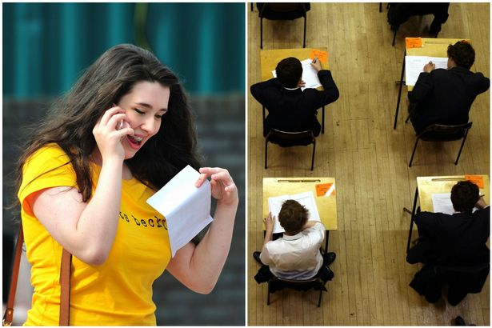
The revised Welsh Bacc has received a high-profile endorsement from the University of Cambridge
Wales’ qualifications system has received a significant commendation after the UK’s top-ranked university confirmed it will treat the new Welsh Baccalaureate as a fourth A-level.
Education Minister Huw Lewis said the fact the prestigious University of Cambridge had promised to value the new graded Welsh Bacc alongside more traditional A-levels showed Wales was developing qualifications “that stand up against the best in the world”.
It comes on the same day that Wales’ new independent qualifications regulator – Qualifications Wales – formally begins its work, marking what the minister has described as an “exciting time for qualifications in Wales”.

'I'm confident it will deliver in Wales'
Mr Lewis said: “The organisation has an important role to play in our education system, regulating awarding bodies and qualifications as well as helping to build public confidence in Welsh qualifications and ensuring they meet the needs of both our learners and our wider economy.
“It is a body built on a sound base of evidence gathered through our qualifications review and I am confident it will deliver for Wales.
“I wish the new chairwoman Ann Evans, the chief executive Philip Blaker and all the staff the very best in these exciting and challenging first few months.”
Mr Lewis said the revised Welsh Bacc – which this summer saw students given an A*, A, B or C grade for the first time – had recently received a high-profile endorsement from the University of Cambridge, which is currently ranked top in both the Guardian and Times and Sunday Times university guides.

'It's a great boost'
He said: “This really is an exciting time for Welsh qualifications as this week Cambridge University has confirmed its decision to join the majority of UK universities in recognising the value of the graded Welsh Bacc and formally using it within their admissions process.
“This endorsement, from the one of the most prestigious universities in the world, shows we are developing first-class, made-in-Wales qualifications that stand up against the best in the world.
“It is a great boost for Qualifications Wales as it begins its first week of work.”
Mr Blaker, who was formerly director of operations at university admissions service Ucas, said: “Qualifications Wales is an independent body which has the full support of educators, employers and politicians to ensure that the standard of exams in Wales are both rigorous and fit for purpose.
“We have assembled a team of talented people whose sole aim is to work in the best interests of learners in Wales.
“We will build on the excellent work that has already been carried out in the sector, including today’s news that Cambridge University will in future accept the new graded Welsh Baccalaureate as an equivalent fourth A-level.”

'We want Welsh students to apply to Cambridge'
Richard Partington, senior tutor at Churchill College, University of Cambridge, said: “Cambridge admissions has decided to accept the new Welsh Bacc as a fourth A-level for the purpose of assessing applications and making offers.
“This decision reflects our interest in the potential value of the personal study within the Bacc as well as its focus upon developing advanced skills. We are keen to encourage highly able Welsh students to apply to Cambridge.”
The qualifications landscape is set to change dramatically across the UK in the coming years, with the traditional three-country exams system starting to break up.
It follows a major review of qualifications in Wales, which was published in November 2012 and attracted representation from leading figures in the education and business sectors.

